**SQOOP — How to install on Windows**

**1.Prerequisites :**

1. [Download SQOOP zip](https://downloads.apache.org/sqoop/1.4.7/)  
   * I am using SQOOP-1.4.7, you can also use any other STABLE version for SQOOP.

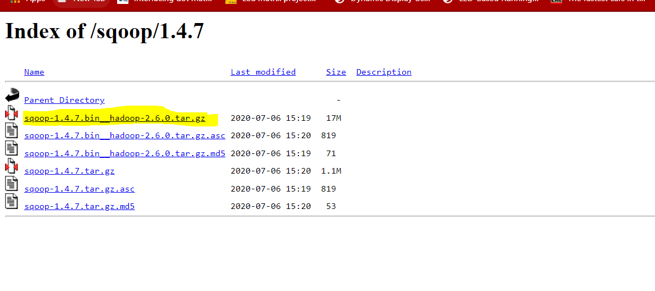

# 2. Unzip and Install SQOOP

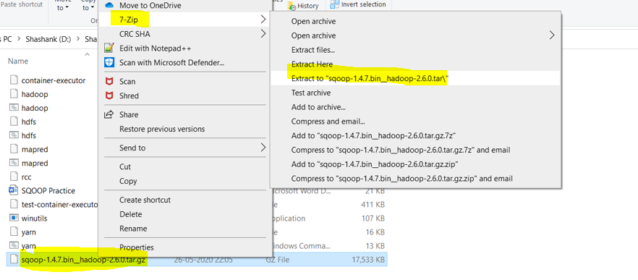After Downloading the SQOOP, we need to Unzip the sqoop-1.4.7.bin__hadoop-2.6.0.tar.gz file.

Once extracted, we would get a new file sqoop-1.4.7.bin__hadoop-2.6.0.tar  
Now, once again we need to extract this tar file.

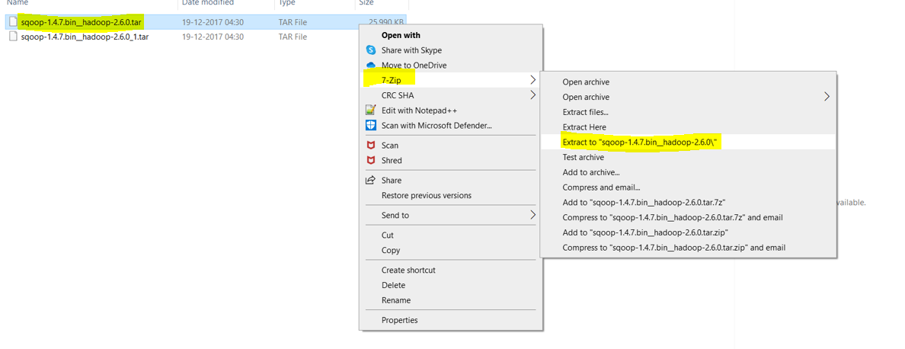

Now we can organize our SQOOP installation, we can create a folder and move the final extracted file in it. For Eg. :-

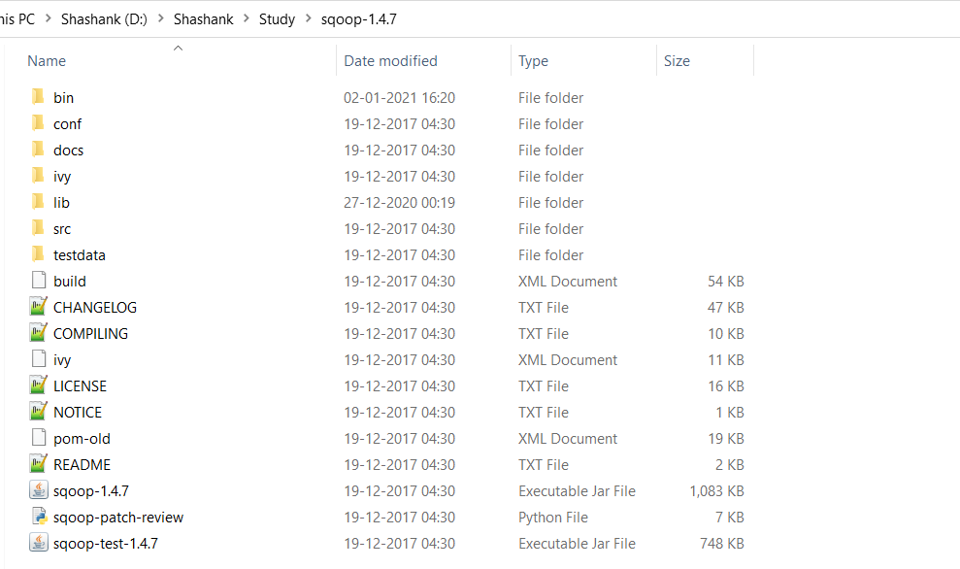

Please note while creating folders, DO NOT ADD SPACES IN BETWEEN THE FOLDER NAME.(it can cause issues later)

I have placed my SQOOP in D: drive you can use C: or any other drive also.

# ****3. Setting Up Environment Variables****

Another important step in setting up a work environment is to set your Systems environment variable.

To edit environment variables, go to Control Panel > System > click on the “Advanced system settings” link  
Alternatively, We can Right click on This PC icon and click on Properties and click on the “Advanced system settings” link  
Or, easiest way is to search for Environment Variable in search bar….

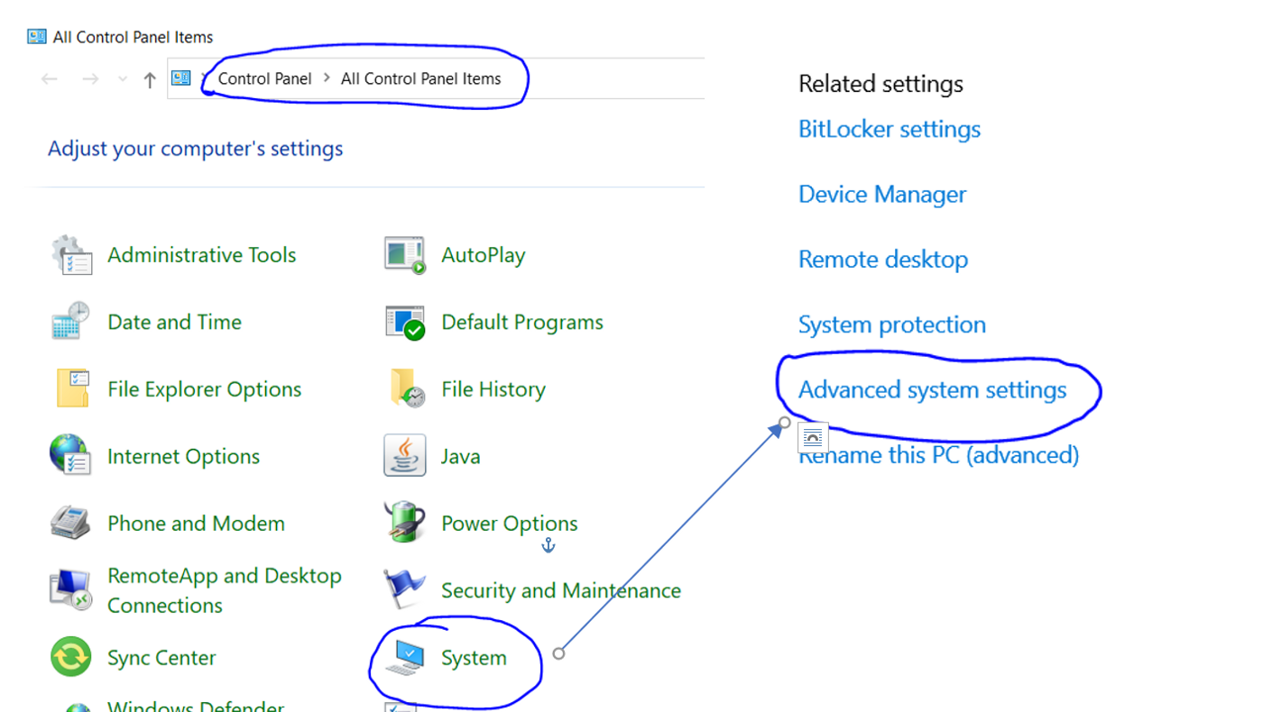

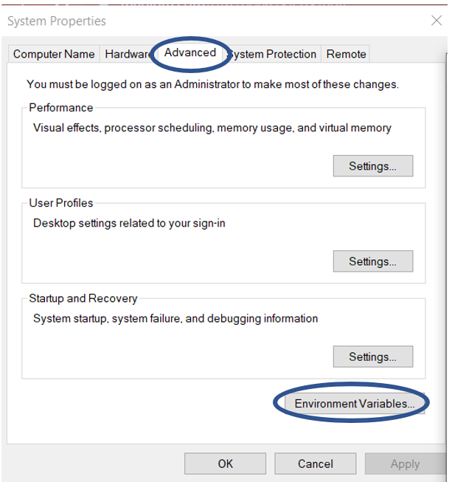

**3.1 Setting SQOOP_HOME**

* Open environment Variable and click on “New” in “User Variable”

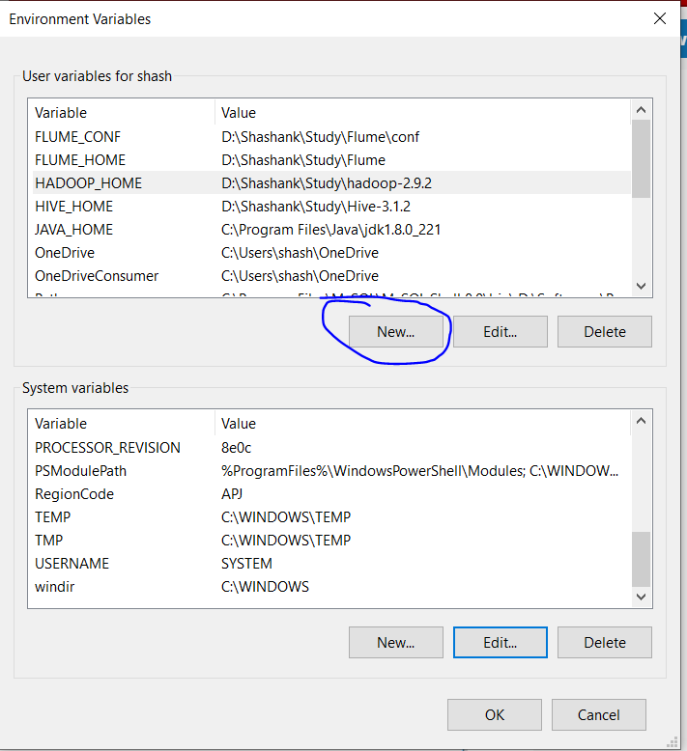

* 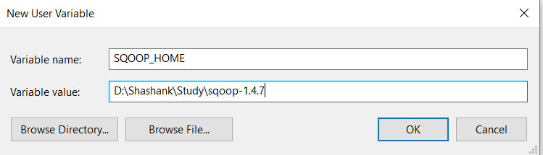On clicking “New”, we get below screen.
* Now as shown, add SQOOP_HOME in variable name and path of SQOOP in Variable Value.
* Click OK and we are half done with setting SQOOP_HOME.

**3.2 Setting Path Variable**

* 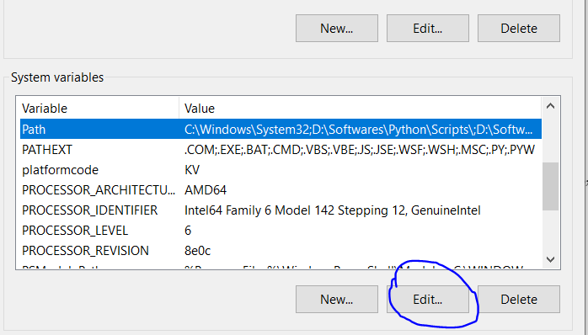Last step in setting Environment variable is setting Path in System Variable.
* 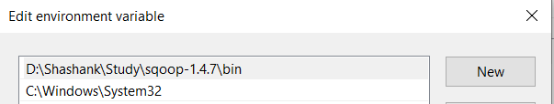Select Path variable in the system variables and click on “Edit”.
* Now we need to add these paths to Path Variable :-  
  * %SQOOP_HOME%\bin
* Click OK and OK. & we are done with Setting Environment Variables.

*Note:- If you want the path to be set for all users you need to select “New” from System Variables.*

**3.3 Verify the Paths**

* Now we need to verify that what we have done is correct and reflecting.
* Open a **NEW** Command Window
* Run following commands

echo %SQOOP_HOME%

# 4. Configure SQOOP

Once we have configured the environment variables next step is to configure SQOOP. It has 3 parts:-

**4.1 Installing MySQL Database**

*If you have already installed MySQL Database or any other Database like MySQL, PostgreSQL, Oracle, SQL Server and DB2 you can skip this step and move ahead.*

I will be using MySQL Database as SQOOP includes fast-path connectors for MySQL.

You can refer [How to install MySQL from HERE](https://dev.mysql.com/doc/mysql-installation-excerpt/8.0/en/mysql-installer.html).

**4.2 Getting MySQL connector for SQOOP**

Download <http://www.java2s.com/ref/jar/download-mysqlconnectorjava8016jar-file.html> and put it in the lib folder of SQOOP.

**4.3 Creating Users in MySQL**

The next important step in configuring SQOOP is to create users for MySQL.  
These Users are used for connecting SQOOP to MySQL Database for reading and writing data from it.

* Firstly, we need to open the MySQL Workbench and open the workspace(default or any specific, if you want). We will be using the default workspace only for now.

